1. Use case of adding products successfully

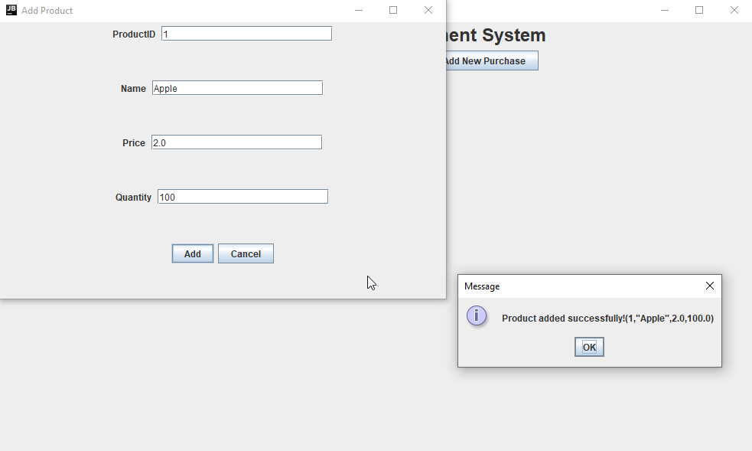

1. Use case of adding products unsuccessfully (duplicate product ID)

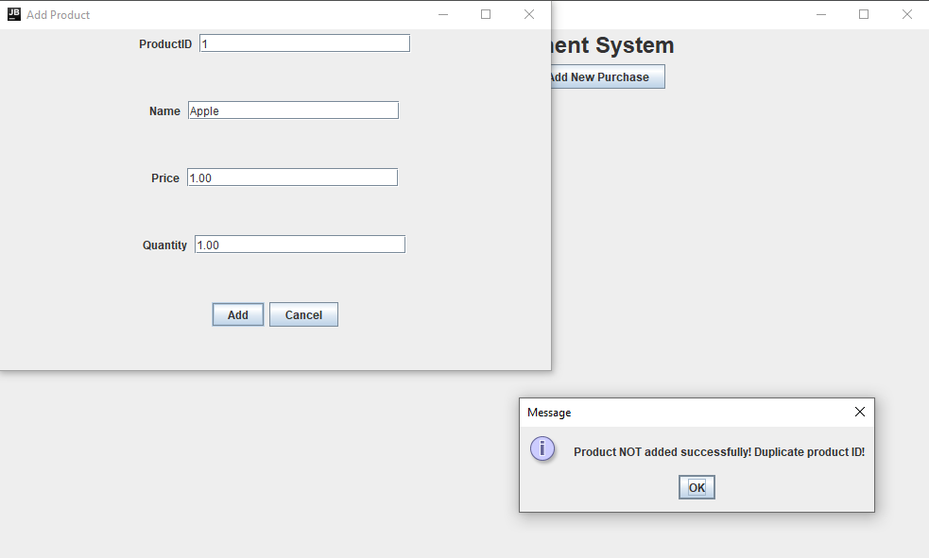

1. Use case of adding customers successfully

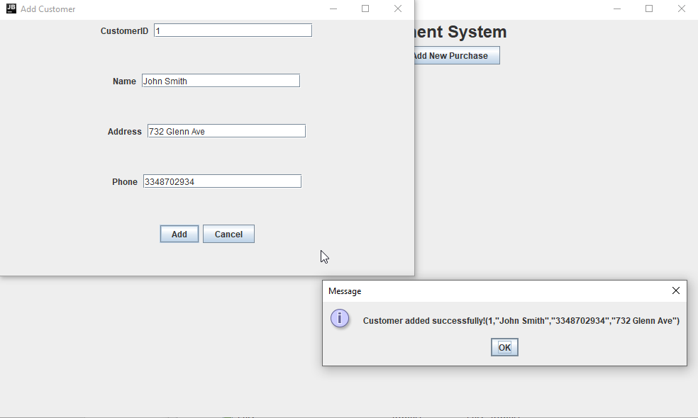

1. Use case of adding products unsuccessfully (duplicate customer ID)

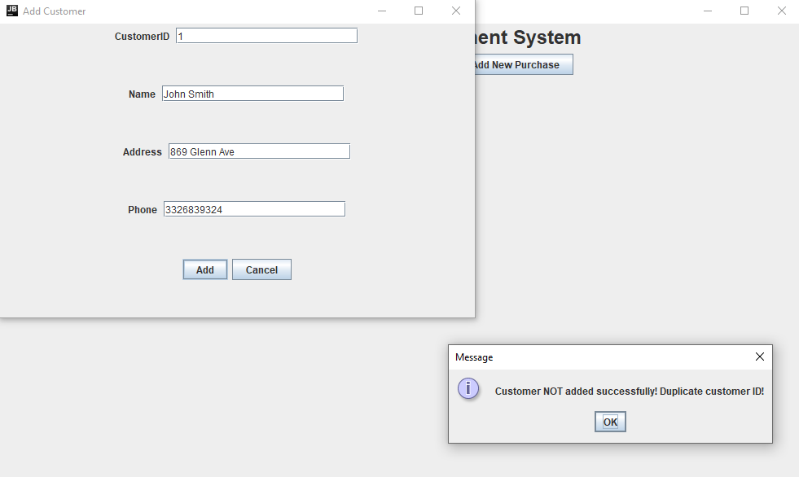

1. Use case of adding purchase successfully

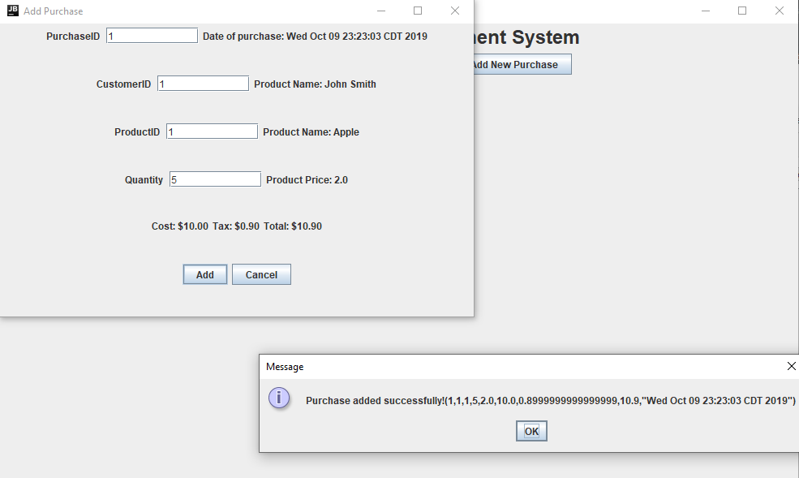

Receipt after adding purchase successfully:

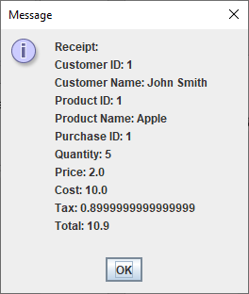

1. Use case of adding purchase unsuccessfully (invalid quantity amount)

